# **Auto C3D Checker - User Guide**

## **What is this?**

This is a tool for automatically evaluating the quality of a biomechanical trial (in .c3d format) involving the use of marker-driven motion capture, forceplates (from here on referred to as FP), and surface EMG.

This tool evaluates the .c3d in terms of its appropriateness for neuromusculoskeletal (from here on referred to as NMS) modelling. Specifically, this tool automatically determines:

* Whether Markers crucial for tracking are present throughout the trial
* If the instrumented leg hits a FP during the trial
  + If yes, which FP is hit and does the foot/both feet hit this FP fully or only partially
  + If FP is hit, at what frame do foot strike and foot off happen
  + If all above are found, the required trial length (foot strike to foot off, plus extra frames for analysis window and EMG delay) is calculated
* If the recorded trial is long enough for the required trial length
  + If not, is there sufficient data to account for EMG delay while padding the trial
  + If yes does start/end/both need padding
  + If required, padding is then performed
* Whether EMG signal quality is sufficient for EMG-assisted NMS modelling
  + If not, how many of the total EMG in the trial are of insufficient quality

Based on these .c3d quality criteria, trials are modified (i.e., start padding) and divided into three groups:

* Calibration – Highest quality trials (where the instrumented leg fully hits a FP and trials have required length) without a need for any data modifications and with at least 75% of EMG being of sufficient quality. These trials can be used to calibrate the NMS model.
* Execution – Trials (where the instrumented leg fully hits a FP) with a need for data modifications (i.e., padding) or with insufficient EMG quality. These trials can be used to run the NMS model, but not to calibrate it.
* Unusable – Trials where the instrumented leg does not hit the FP (or not fully), or where not enough data is present to account for EMG delay for padding.

The checker outputs a “Results.xlsx” containing the results of all the abovementioned checks for all participants. Further, it creates an “EMG Figures” folder for each participant, where the classified EMG can be found. Furthermore, it creates an “InputData” folder and places the modified Calibration/Execution .c3d trials into appropriate folders.

## **Inputs**

To use the Auto C3D Checker, the following folder structure is required (see an example in the included Sample Data):

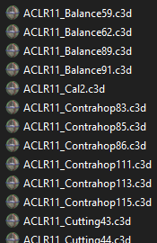

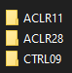

The “Base Folder” contains participant folders, which contain the .c3d files (it’s best to have the participant in the .c3d files name to avoid confusion).

Furthermore, an .xml setup file providing additional information and settings is required (acquisition_example.xml can be found in the “templatesXML” folder):

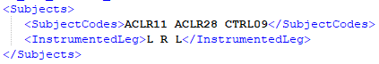

SubjectCodes – Participant folder names in your Base Folder.  
  
InstrumentedLeg – Instrumented leg for the participants (same order as the participant folders)

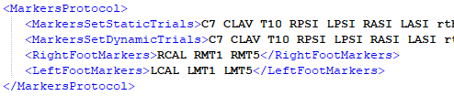

MarkersSetDynamicTrials – Required markers in all dynamic trials (if required markers are missing, script might throw an error)   
  
Right/LeftFootMarkers – Markers on the right/left foot (used to determine foot strike and full foot on FP)

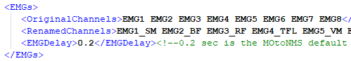

OriginalChannels – Channel names of your EMG in all .c3d  
  
RenamedChannels – Optional entry to rename EMG channel names ion all .c3d (this option is enabled in the script with overwriteEMGNames = true;)disabled in the script if not required   
  
EMGDelay – Value for electromechanical + hardware delay (0.2 sec is the MOtoNMS default, don’t change without a good reason!)

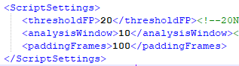

thresholdFP – FP threshold, only change if encountering errors  
  
analysisWindow – Extra frames for analysis window (10-25 is standard for CEINMS)  
  
paddingFrames – How many frames to pad trials with (100 is sufficient in most cases)



Lastly, the paths to both the base data folder and the .xml setup file need to be adjusted to point at your data inside the main script.

## **Outputs**

1) The script outputs the modified trials for each participant in their respective InputData folders:

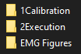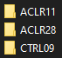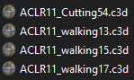

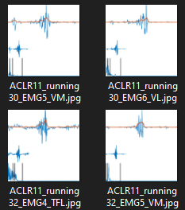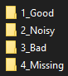2) The EMG are classified and save into their respective class folders:

3) The .c3d quality checking results are saved for each investigated trial (even the unused ones) in an Excel file:





## **Future direction**

Future direction for this tool includes:

* Function to automatically generate acquisition.xml for each participant’s calibration & execution folders
* Function to re-classify manually re-sorted EMG images (in case you disagree with the automatic classification) and update the Results.xlsx
* Function to automatically generate trial specific excitationGenerator.xml and other CEINMS setup files where bad quality EMG are synthesized (instead of having a single setup file for the whole acquisition)
* GUI to increase the ease of use